School of Computer Science Engineering & Information Science
A Report on Mini-Project Titled “Enrollment Management”

Course Title: Web Technologies
Course Code: CSE2258

Date of Submission: 22/11/2025

Submitted By:
Name | Roll Number
Sameeksha Dinesh | 20241IST0101
Sanjay B | 20241IST0103
Chandrakant K | 20241IST0104
Kounain Abbas | 20241IST0105

Index
- Abstract
- Introduction
- Software and Hardware Requirements
- Modules/Functionalities
- Results with Screenshots
- Conclusion

01. Abstract :
The Enrollment Management System (EMS) is a web-based application designed to simplify and automate the student enrollment process in educational institutions. Traditional enrollment methods often rely on manual data entry, paperwork, and in-person verification, leading to errors, delays, and difficulty in managing large volumes of student records. This system provides a digital platform for students to register, upload documents, select courses, and track enrollment status, while administrators can verify applications, manage academic programs, and generate reports efficiently. The system enhances accuracy, accessibility, transparency, and operational efficiency.
02. Introduction :
Enrollment is a critical process in schools, colleges, and universities as it determines the admission and academic planning for each term. Manual enrollment systems are typically time-consuming, prone to errors, and lack real-time data accessibility. With the growing need for digital transformation in education, a web-based Enrollment Management System becomes essential.
The proposed EMS allows students and administrators to interact through a centralized online portal. Students can create accounts, fill out enrollment forms, choose courses, and receive updates. Administrators can monitor applications, manage academic records, and handle course capacities. This project aims to provide a secure, user-friendly, and scalable platform to manage end-to-end enrollment processes.

03. Software and Hardware Requirements :
Software Requirements
- Frontend: HTML5, CSS3, JavaScript, Bootstrap
- Backend: PHP / Python (Django/Flask) / Node.js (any server-side stack)
- Database: MySQL / PostgreSQL / MongoDB
- Web Server: Apache / Nginx
- Operating System: Windows / Linux / macOS
- Browser: Chrome, Firefox, Edge
- Development Tools: VS Code, XAMPP/WAMP (if using PHP), Git (optional)
Hardware Requirements
- Client-Side:
  - Processor: Minimum 1.6 GHz
  - RAM: 2 GB or more
  - Internet connection
- Server-Side:
  - Processor: Dual-core 2.0 GHz or higher
  - RAM: Minimum 4 GB
  - Storage: 20 GB or more
  - Stable network connection for hosting
04. Modules :
User Module
- Student registration and login
- Profile management
- Secure authentication (password hashing, OTP/email verification optional)
Student Enrollment Module
- Online enrollment form submission
- Document upload (ID proof, previous academic records, etc.)
- Course selection with available seat tracking
- Enrollment status tracking (Pending, Approved, Rejected)
Administrator Module
- Admin login/dashboard
- View and verify student applications
- Approve/Reject applications
- Manage courses, departments, schedules, and seat capacity
- Manage academic sessions/semesters
Course Management Module
- Add/Edit/Delete courses
- Set prerequisites
- Assign instructors (optional)
- Track enrolled students
Notification & Communication Module
- Email/SMS/Portal notifications
- Status updates for enrollment
- Announcements dashboard
Reporting Module
- Generate student enrollment statistics
- Course-wise enrollment report
- New admissions report
- Export data to Excel/PDF
Security Features
- Role-based access control (Admin/Student)
- Input validation
- Protection against SQL injection and CSRF
- Encrypted password storage

05 . Results :
The implemented Enrollment Management System successfully automates and streamlines the entire admission and course registration process. Students can enroll online without requiring physical presence, reducing paperwork and administrative workload. Administrators are able to instantly verify student data, manage academic programs, and monitor enrollment statistics. The system displays real-time updates, reduces processing time, improves accuracy, and enhances overall transparency. User testing indicated improved satisfaction and significantly fewer errors compared to manual methods.


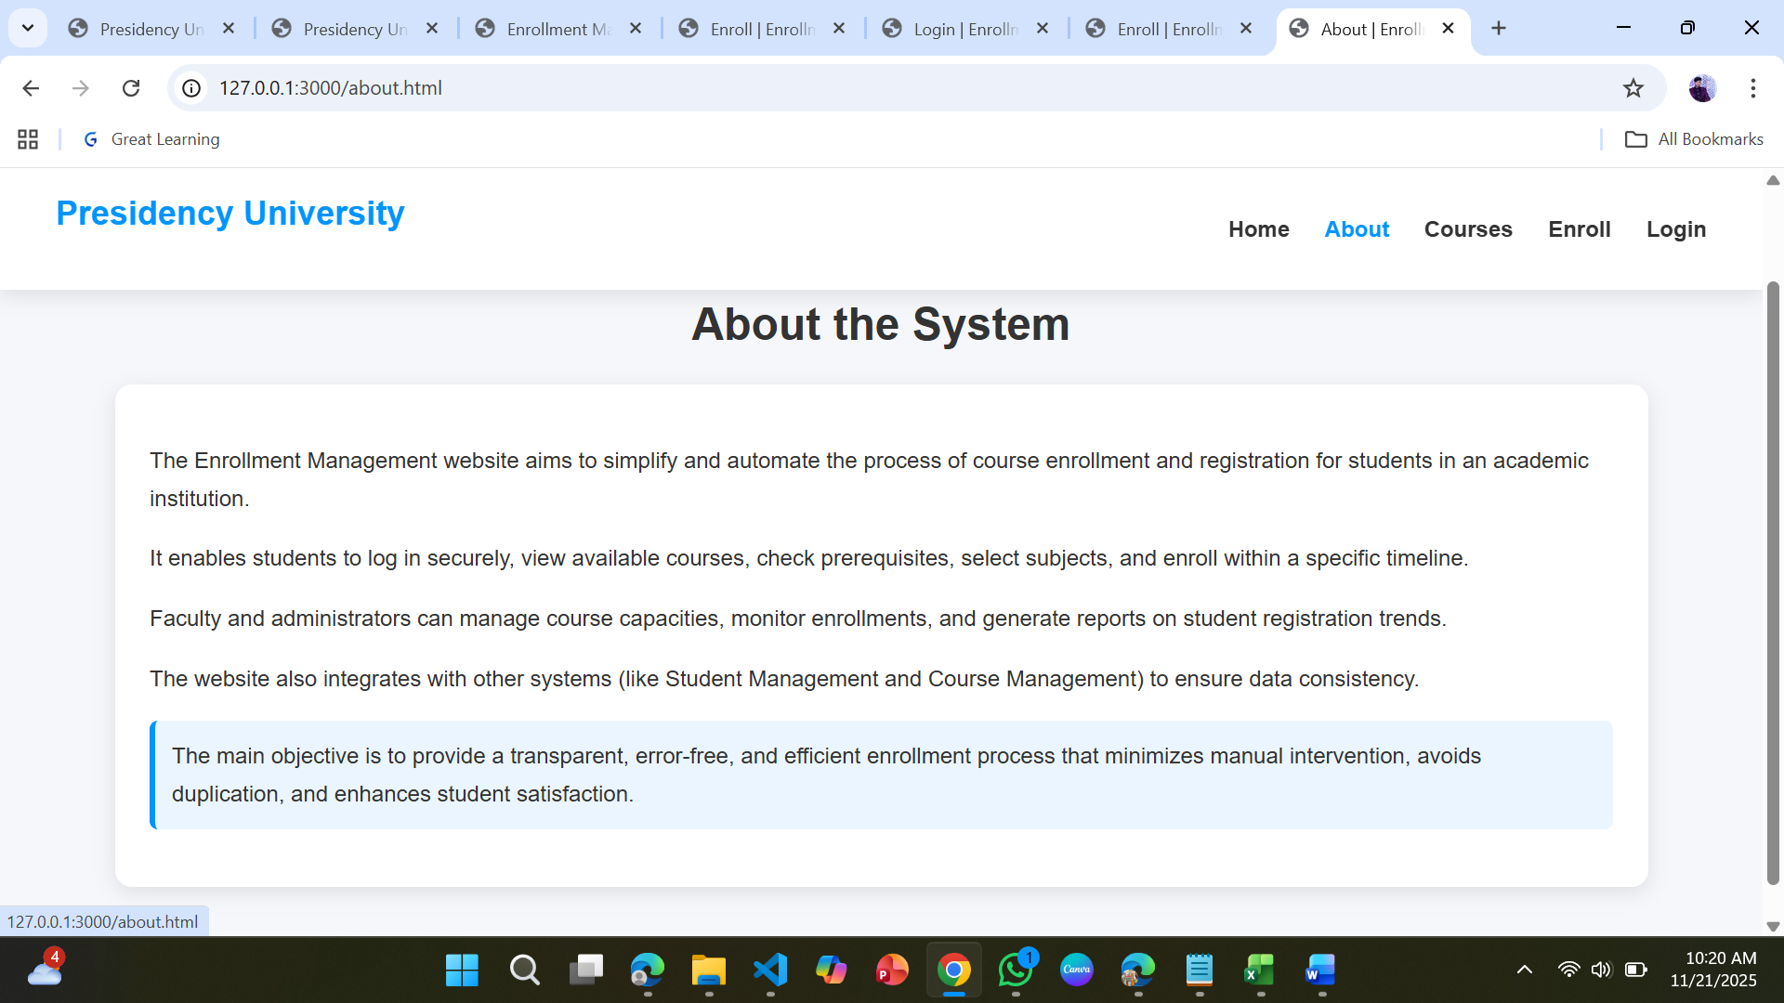

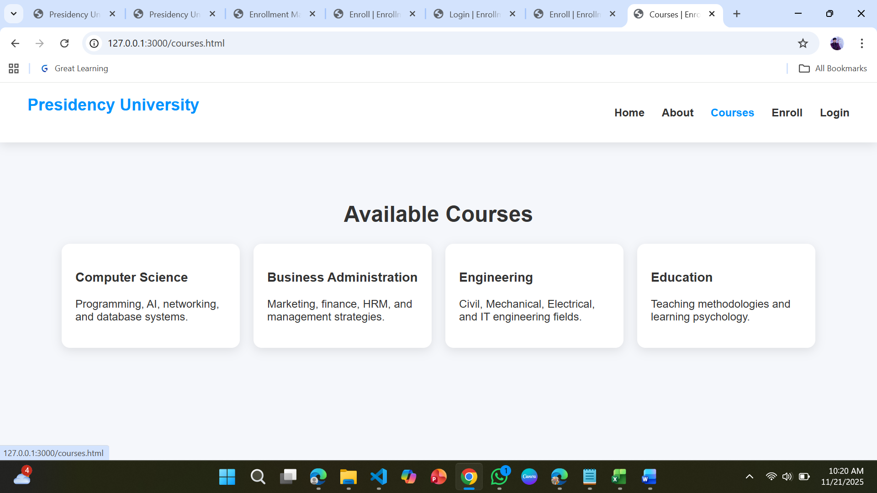

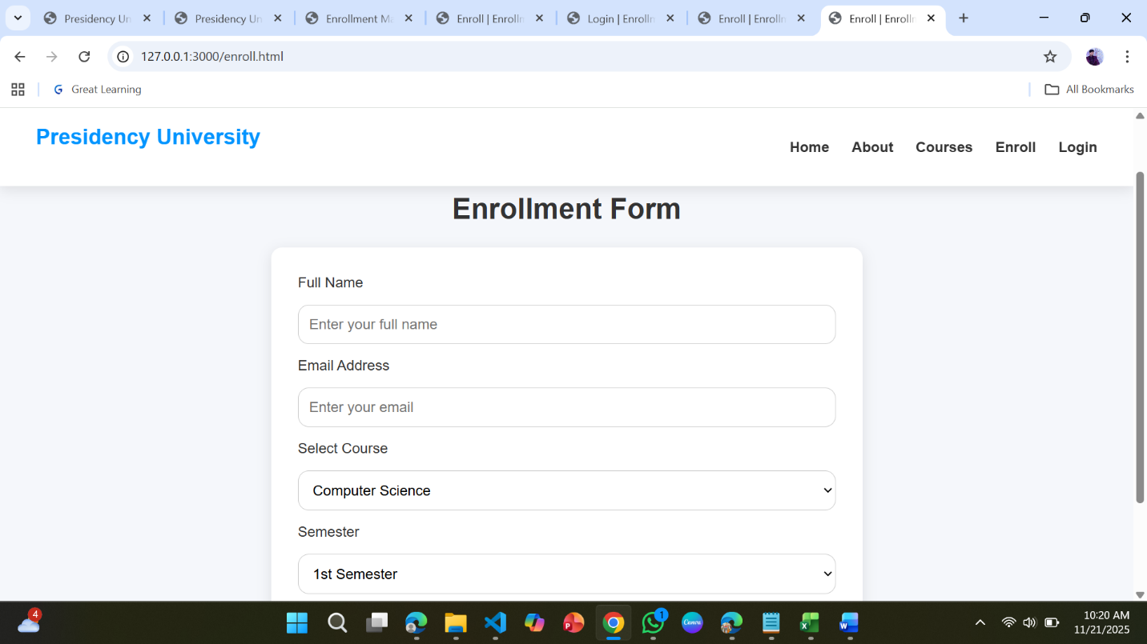

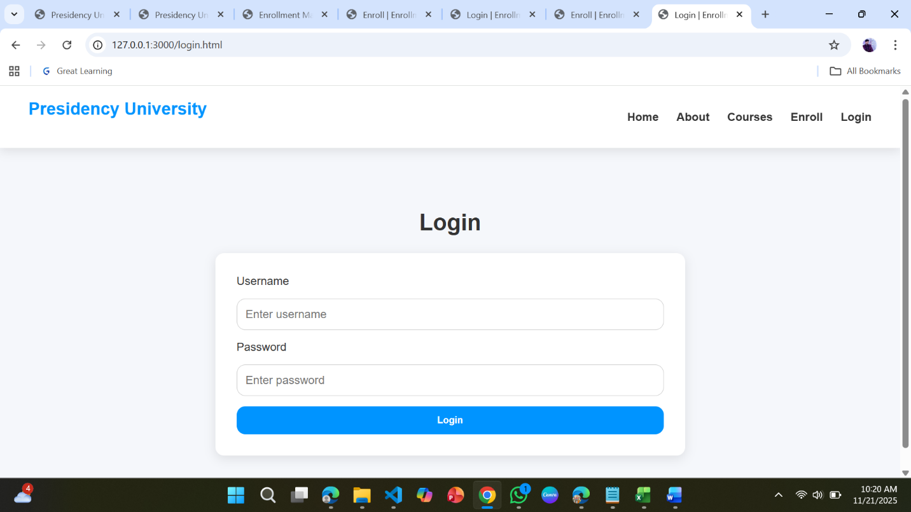

06. Conclusion :
The Enrollment Management System provides an efficient and reliable solution for modernizing the student enrollment process. By digitizing critical workflows, the system reduces administrative burdens, minimizes errors, and offers a seamless experience for students and staff. Its modular design ensures scalability for future enhancements such as payment integration, mobile apps, and advanced analytics. This project demonstrates how web technologies can transform institutional operations and support academic success through better resource and data management.

